Sir Syed University of Engineering and Technology

*Department of Computer Engineering*

*CE-301L Database Management System*

*Fall Semester 2024*

***Project Report***

**Project Title: Freelancer Work Tracking System**



**Submitted By:**

|  |  |  |
| --- | --- | --- |
| **S. No.** | **Name** | **Roll#** |
| **1.** | **Muzammil Ahmed Ansari** | **2022F-BCE-09** |
| **2.** | **Farhan Ali** | **2022F-BCE-45** |
| **3.** | **Salman Khan** | **2022F-BCE-01** |
| **4.** | **Muhammad Jon Abbas** | **2022F-BCE-029** |

**Submitted To:**

**Miss Faiza Farooq**

**GROUP MEMBERS :**

|  |  |
| --- | --- |
| **Group Members Name** | **Roll Number** |
| **SALMAN KHAN** | **2022F –BCE – 01** |
| **MUZAMMIL AHMED (Gl)** | **2022F –BCE – 09** |
| **M.JON ABBAS** | **2022F –BCE –29** |
| **FARHAN ALI** | **2022F –BCE –45** |

**PROJECT TOPIC :**

**FREELANCE WORK TRACKING SYSTEM**

**Table Of Content**

1) Acknowledgement .………………………….….... 3

2) Abstract .…..…………………………………...…... 3

3) Introduction ………………………………………... 5

5) Methodology …………………………..……..…..6 - 11

5.a) Database Schema…………………………….

5.b) ERD (with relational mapping) ………………..

5.c) Normalization ………………………………..

5.d) Theoretical description with definitions ……..

6) Result (Output)……………………….……………..15

7) Conclusion ….….…………………………………… 16

**Acknowlegdement**

*No volume is enough to express my gratitude towards my guide* ***MISS FAIZA FAROOQ*** *who have been very concerned and has aided for all the material essential for the preparation of this this report.*

*I would also like to thanks the staff members and my friends who were always there at the need and provided all the help and facilities, which I required for the completion of my work.*

*Lastly, I would like to thank my parents, university mates and the Almighty for showing me the right direction out of the blue, to help me stay calm in the oddest of the times and moving even at times there was no hope.*

***.……………………………………………………………***

**Abstract:**

This project involves the development and implementation of a **Freelance Work Tracking System** which is basically web application designed to streamline task management and provide insightful analytics for freelance projects. It enables users to perform **CRUD operations (Create, Read, Update, Delete)** for effective task handling while offering features such as revenue tracking, deadline monitoring, role assignments, platform usage, and status visualization. The system incorporates dynamic graphs and charts to showcase key metrics like project progress, revenue trends, and task completion rates, empowering users to make informed decisions and optimize resource utilization. Built with HTML, CSS, and Python(Flask), the application ensures seamless functionality and a user-friendly experience, promoting productivity and data-driven project management.

**Introduction**

The **Freelance Work Tracking System** is a **versatile web application** designed to simplify project management and enhance productivity for freelancers. It offers a centralized platform for efficient task handling through **CRUD operations (Create, Read, Update, Delete)** while providing advanced features such as revenue tracking, deadline monitoring, role assignments, platform usage analysis, and project status visualization. Dynamic graphs and charts present clear insights into metrics like project progress, revenue trends, and task completion rates, empowering freelancers to make informed decisions and optimize workflows. Built **with HTML, CSS, Python (Flask), and SQLite** for database management, the system ensures a user-friendly interface, robust backend functionality, and effective data storage, delivering streamlined and reliable project management.

**Methodology:**

* ) Database Schema

Describe the structure of your database. Include tables, columns, and their data types.

**Example:**

**Users Table:** Contains details about the freelancers.

id (INTEGER, Primary Key)

full_name (TEXT, NOT NULL)

email (TEXT, UNIQUE, NOT NULL)

password (TEXT, NOT NULL)

role (TEXT, NOT NULL)

**Projects Table:** Stores information about projects assigned to freelancers.

id (INTEGER, Primary Key)

user_id (INTEGER, Foreign Key referencing Users)

project_name (TEXT, NOT NULL)

deadline (TEXT, NOT NULL)

revenue (REAL, NOT NULL)

platform (TEXT, NOT NULL)

status (TEXT, NOT NULL)

* ) ERD (with relational mapping)

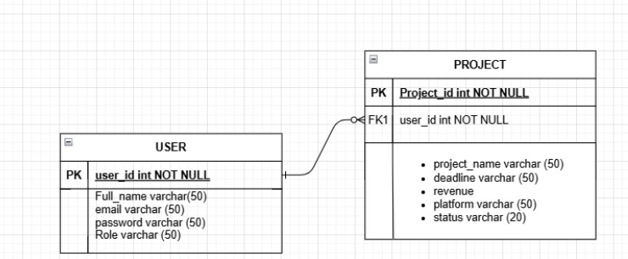

* ) Normalization

### **Normalization of Freelance Work Tracking System**

#### ****1NF (First Normal Form)****

* **Atomic values**: Each column has indivisible values.
* **Unique rows**: Each record has a unique identifier (Primary Key).

**Client Table**

| **Client_ID (PK)** | **Name** | **Email** | **Phone** | **Address** |
| --- | --- | --- | --- | --- |
| 1 | John Doe | [john@example.com](mailto:john@example.com) | 1234567890 | 123 Main St. |

**Project Table**

| **Project_ID (PK)** | **Client_ID (FK)** | **Project_Name** | **Status** |
| --- | --- | --- | --- |
| 101 | 1 | Website Design | In Progress |

**Task Table**

| **Task_ID (PK)** | **Project_ID (FK)** | **Task_Description** | **Assigned_To** | **Status** |
| --- | --- | --- | --- | --- |
| 1001 | 101 | Create homepage | John Doe | In Progress |

#### ****2NF (Second Normal Form)****

* **1NF + No partial dependency**: Non-key attributes must depend on the entire primary key.

**Project Table**

* No partial dependencies; all attributes depend on **Project_ID**.

**Task Table**

* Non-key attributes depend on **Task_ID** only, no partial dependencies.

#### ****3NF (Third Normal Form)****

* **2NF + No transitive dependency**: Non-key attributes should not depend on other non-key attributes.

**Client Table**

* No transitive dependency, all attributes depend on **Client_ID**.

**Project Table**

* No transitive dependency, attributes depend directly on **Project_ID**.

### **Additional Tables**

* **Revenue Table**: Stores project revenue.
* **Deadline Table**: Tracks task deadlines.
* **Role Assignment Table**: Assigns roles to users.
* **Platform Usage Table**: Tracks platform usage metrics.

This normalization ensures efficient storage, reduces redundancy, and maintains data integrity.

* ) Theoretical description with definitions

A **Freelancer Work Tracking System** is a comprehensive tool specifically designed to help freelancers manage their day-to-day tasks, time, finances. Freelancers often juggle multiple projects, clients, and deadlines, and this system helps streamline these activities into one organized platform. It offers a range of features that allow freelancers to track their productivity, meet deadlines, ensure accurate payments history.

### Key Features:

1. **Project Management**: Helps freelancers organize tasks, set deadlines, and track project progress.
2. **Time Tracking**: Records hours worked on different tasks or projects, either manually or automatically.
3. **Client Management**: Stores client information, project details, and payment history.
4. **Invoicing and Payments**: Allows freelancers to create and send invoices, track payments, and manage finances.
5. **Expense Management**: Helps track business expenses like tools, travel, or supplies.
6. **Productivity Analytics**: Provides reports on time spent, task completion, and performance trends.
7. **Collaboration Tools**: Enables freelancers to communicate and share files with clients or team members.
8. **Contract Management**: Helps create, store, and manage contracts with clients.
9. **Notifications**: Sends reminders for deadlines, payments, and project updates.
10. **Reporting and Dashboard**: Displays key metrics, like hours worked and income, in an easy-to-understand format.

### Benefits:

* **Saves time**: Automates tasks like time tracking and invoicing.
* **Keeps things organized**: Consolidates all work, client, and financial information in one place.
* **Improves productivity**: Helps freelancers track performance and optimize workflows.
* **Better client relations**: Ensures timely communication and payments, improving client satisfaction.

**Result:**

**SIGN UP:**

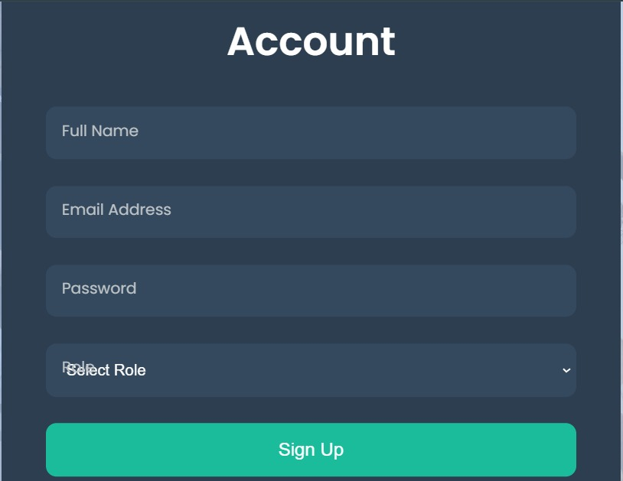

**LOG IN:**

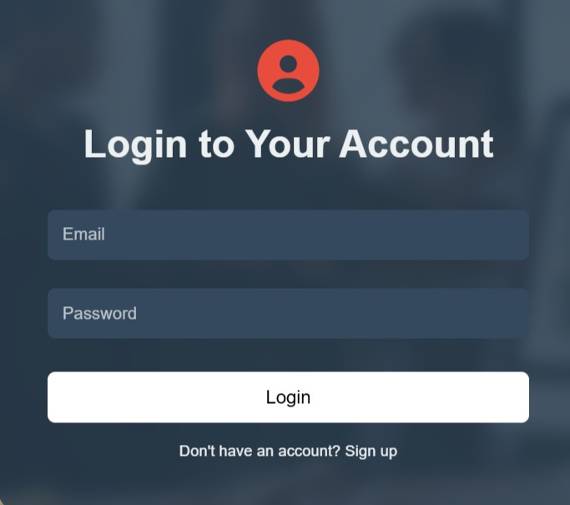

**DASHBOARD:**

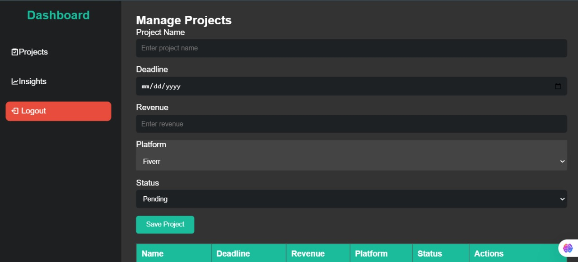

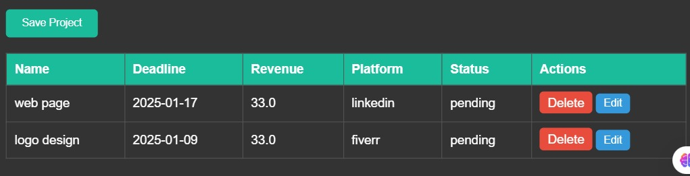

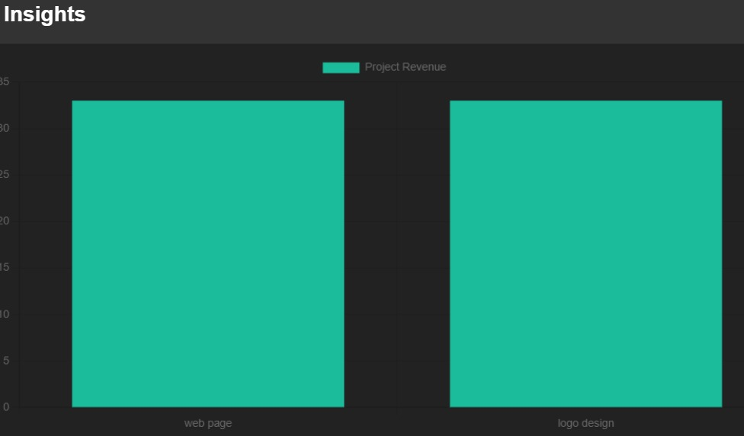

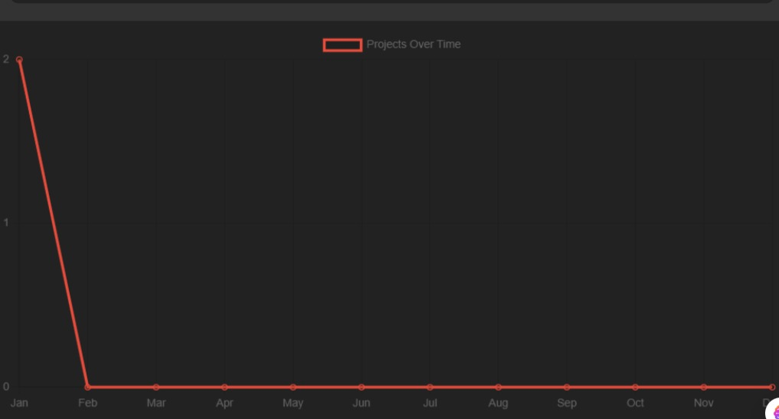

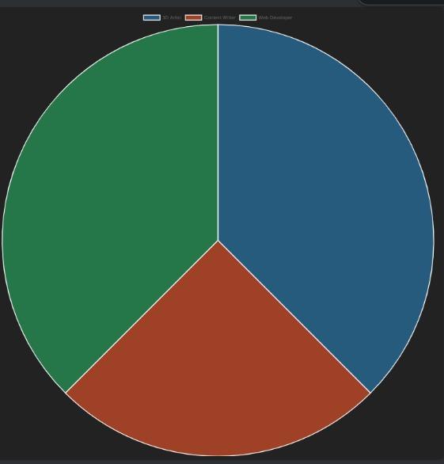

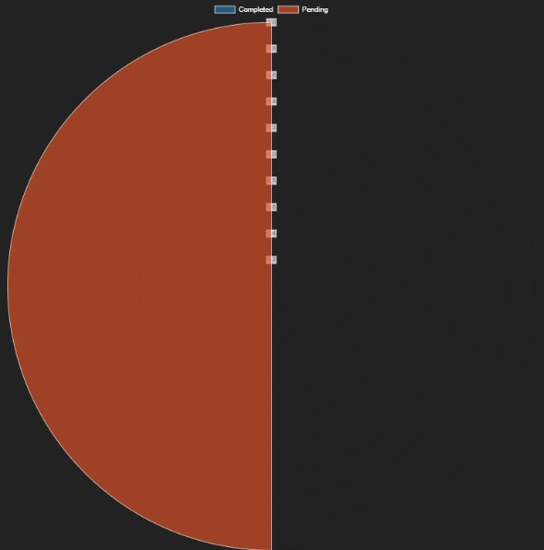

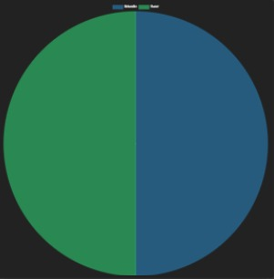

**Conclusion:**

The **Freelance Work Tracking System** demonstrates an efficient approach to managing freelance projects by integrating user authentication, project tracking, and insightful analytics. Using SQLite as the backend database ensures lightweight and efficient data handling, while Flask provides a robust and scalable web application framework. Features such as dynamic project dashboards, JSON APIs, and CRUD operations streamline workflows, enabling users to track projects, monitor deadlines, and analyze revenue effectively. Future improvements, such as password hashing and advanced analytics, could further enhance security and functionality, making it an indispensable tool for freelancers.